Chapter 9 Outline

Lesson 1: The Nature of Chemical Reactions

-Chemical reaction is a process in which one or more substances are converted into new substances with different physical and chemical properties

-Reactant what enters a chemical reaction

-Product what reactant become after the reaction

Lesson 2: Chemical Equations

* Chemical reactions are represented by sentences known as chemical equations

Calcium + Oxygen => Calcium Oxide

* Word equation most simplest form

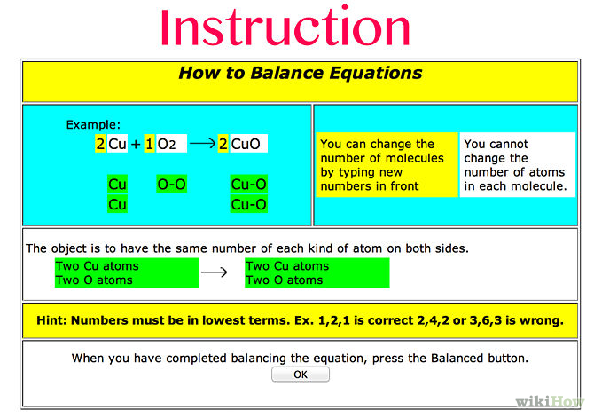

* For mass to remain constant before and after a chemical reaction, the number of atoms of each element must be the same before and after a chemical reaction
* Coefficients whole numbers written before the formulas for reactants and products